Assignment 33: Introduction to DevOps
Objective.
To install Jenkins, create a Freestyle job, build Jenkins Pipelines with GitHub checkout, add automated testing and failure handling, and use AI assistance to create a CI/CD Jenkinsfile for a Zomato-style food ordering application.

Software / Requirements
- Windows/Linux/macOS local machine.
- Docker Desktop (recommended for local Jenkins installation) or a native Jenkins installation.
- Web browser.
- Internet connection.
- A public GitHub repository.

Practical 1 – Install Jenkins and Verify the Dashboard
Recommended method: run Jenkins as a Docker container. Open PowerShell on Windows and execute the following commands.
docker pull jenkins/jenkins:lts
docker run -d --name jenkins `
-p 8080:8080 `
-p 50000:50000 `
-v jenkins_home:/var/jenkins_home `
jenkins/jenkins:lts
docker ps
Open the Jenkins dashboard in a browser:
http://localhost:8080
For the initial administrator password, run:
docker exec jenkins cat /var/jenkins_home/secrets/initialAdminPassword
Copy the displayed password into Jenkins. Select Install suggested plugins, create the administrator account, and complete the setup.

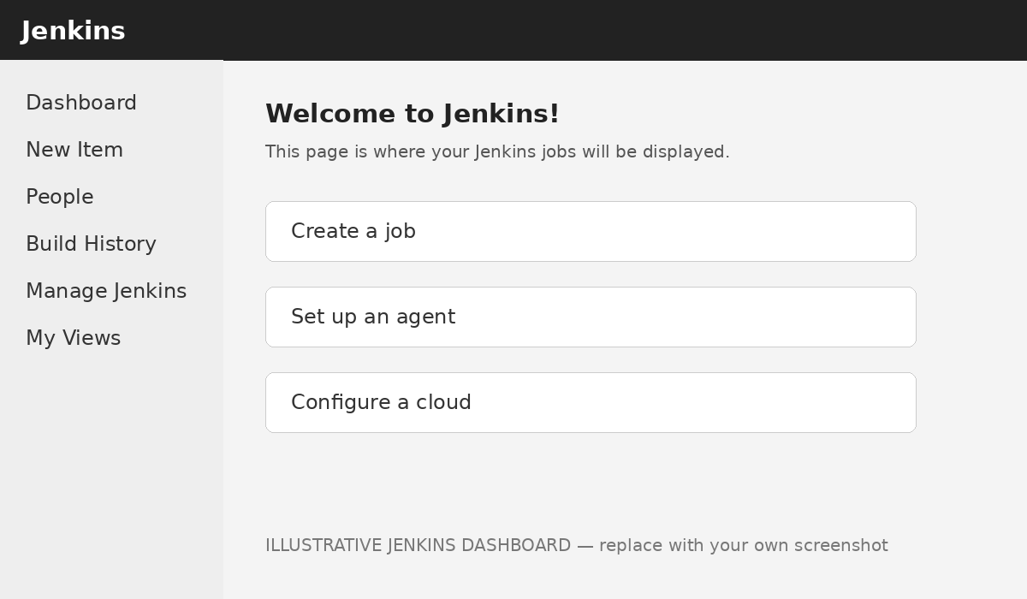
Result: Jenkins was successfully installed and configured using Docker. The Jenkins dashboard was accessed through localhost:8080, confirming that the installation was successful.

Practical 2 – Create SpotifyPlaylistBuild Freestyle Job
1. Open Jenkins Dashboard → New Item.
2. Enter the job name:
SpotifyPlaylistBuild
3. Select Freestyle project and click OK.
4. Scroll to Build Steps → Add build step → Execute Windows batch command.
5. Enter:
echo Building Spotify Playlist App
6. Click Save.
7. Click Build Now.
8. Open the build number (for example #1) → Console Output.
Expected output:
Building Spotify Playlist App
Finished: SUCCESS

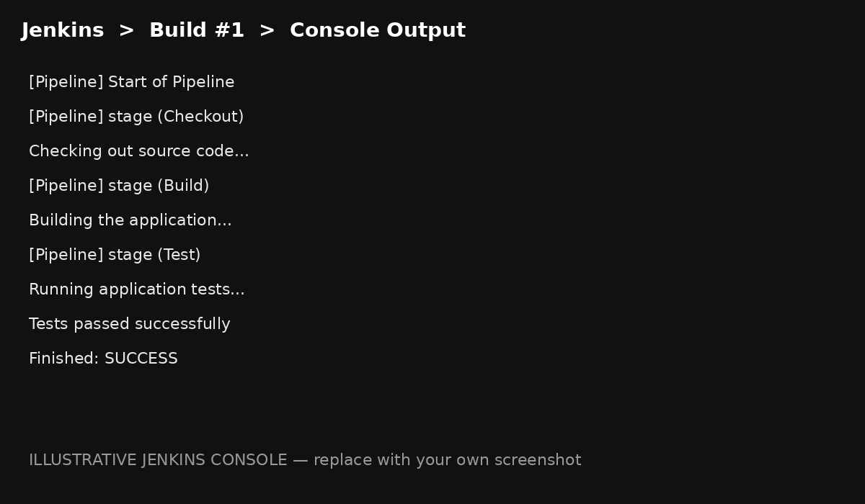
Result: A Freestyle Jenkins project named SpotifyPlaylistBuild was created and executed successfully. The configured message appeared in the console output.

Practical 3 – Basic Jenkins Pipeline with GitHub Checkout
1. Select Dashboard → New Item.
2. Enter:
GitHubCheckoutPipeline
3. Select Pipeline and click OK.
4. Scroll to Pipeline → Definition and select Pipeline script.
5. Paste the following Jenkinsfile:
pipeline {
agent any
stages {
stage('Checkout') {
steps {
git 'https://github.com/octocat/Hello-World.git'
}
}
stage('Build') {
steps {
echo 'Building the application...'
}
}
}
}
6. Click Save → Build Now.
7. Open Build #1 → Console Output.
The pipeline should execute the Checkout and Build stages and finish with SUCCESS.
[ SCREENSHOT PLACEHOLDER: GitHub Checkout + Build Pipeline Console ]
Pipeline flow:
GitHub Repository
↓
Checkout
↓
Build
↓
SUCCESS
Result: A Jenkins Pipeline was created using Pipeline Script syntax. The Checkout stage cloned a public GitHub repository, and the Build stage simulated the application build using an echo command.

Practical 4 – Add a Test Stage and Demonstrate Failure

A. Successful Test Stage
Modify the pipeline by adding a Test stage:
pipeline {
agent any
stages {
stage('Checkout') {
steps {
git 'https://github.com/octocat/Hello-World.git'
}
}
stage('Build') {
steps {
echo 'Building the application...'
}
}
stage('Test') {
steps {
echo 'Running application tests...'
bat 'echo Tests passed successfully'
}
}
}
}
Save the pipeline and click Build Now. Expected output:
Building the application...
Running application tests...
Tests passed successfully
Finished: SUCCESS
[ SCREENSHOT PLACEHOLDER: Test Stage – Successful Build ]

B. Simulate a Failed Test
Replace the Test stage with the following code:
stage('Test') {
steps {
echo 'Running application tests...'
bat 'exit /b 1'
}
}
Run the pipeline again. Jenkins should detect the non-zero exit code and mark the build as FAILURE.
Running application tests...
script returned exit code 1
ERROR: script returned exit code 1
Finished: FAILURE
[ SCREENSHOT PLACEHOLDER: Test Stage – FAILURE / exit code 1 ]
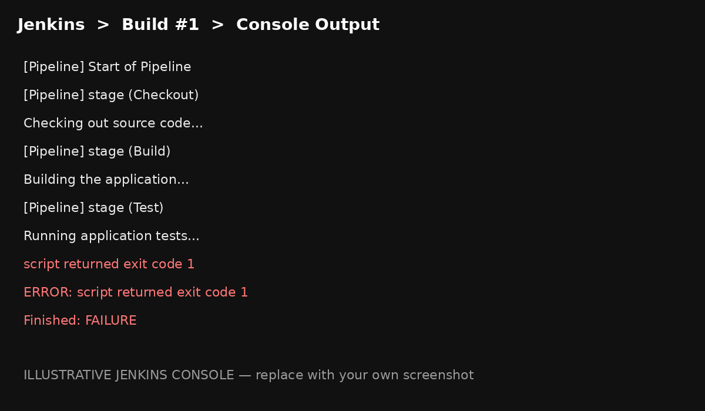
Note: On Windows Jenkins agents, use exit /b 1. On a Linux/macOS agent, the equivalent command is exit 1.
Result: The Test stage successfully demonstrated Jenkins failure handling. A non-zero exit code caused Jenkins to mark the pipeline as failed.

Practical 5 – AI-Assisted Jenkinsfile for a Zomato-Style Food Ordering App
AI Tool Used: ChatGPT
The following Jenkinsfile was generated with AI assistance. It demonstrates a CI/CD workflow for a placeholder Zomato-style food ordering application. The pipeline contains Checkout, Build, Test and Deploy stages.
pipeline {
agent any
environment {
APP_NAME = 'ZomatoStyleFoodApp'
}
stages {
stage('Checkout') {
steps {
echo "Checking out ${APP_NAME} source code"
git 'https://github.com/octocat/Hello-World.git'
}
}
stage('Build') {
steps {
echo 'Building Zomato-style food ordering application...'
bat 'echo Installing frontend and backend components'
bat 'echo Build completed successfully'
}
}
stage('Test') {
steps {
echo 'Running food ordering application tests...'
bat 'echo Testing user login'
bat 'echo Testing restaurant search'
bat 'echo Testing food ordering'
bat 'echo Testing checkout process'
bat 'echo All tests passed successfully'
}
}
stage('Deploy') {
steps {
echo 'Deploying application...'
bat 'echo Deployment completed successfully'
}
}
}
post {
success {
echo 'CI/CD pipeline completed successfully!'
}
failure {
echo 'CI/CD pipeline failed. Check the console output.'
}
always {
echo 'Pipeline execution finished.'
}
}
}
Create a new Jenkins Pipeline job, paste this script under Pipeline → Definition → Pipeline script, save it, and select Build Now.
[ SCREENSHOT PLACEHOLDER: ZomatoStyleFoodApp – Pipeline Execution ]
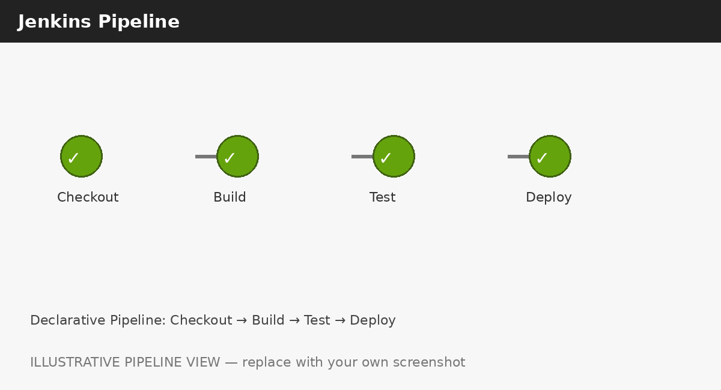

Important Note About npm Testing
The example GitHub repository used above is only a public checkout example and is not necessarily a Node.js application. Therefore, commands such as npm install and npm test may fail if the repository does not contain package.json and configured tests. For a classroom demonstration, the AI-assisted version above uses simulated build, test and deployment commands so that the CI/CD workflow can be demonstrated without depending on a specific Node.js project structure.

AI Errors / Improvements Observed
An AI-generated Jenkinsfile may assume that the checked-out repository is a Node.js application. If the repository does not contain package.json or test scripts, npm install or npm test will fail. The Jenkinsfile was therefore improved by separating the stages clearly and using simulated commands for the placeholder application. In a real project, these commands should be replaced with the project's actual package manager, build tool, automated tests and deployment process.

Overall CI/CD Workflow
GitHub Repository
│
▼
┌─────────────┐
│ CHECKOUT │
└──────┬──────┘
│
▼
┌─────────────┐
│ BUILD │
└──────┬──────┘
│
▼
┌─────────────┐
│ TEST │
└──────┬──────┘
│
┌──────┴──────┐
│ │
PASS FAIL
│ │
▼ ▼
DEPLOY FAILURE
│
▼
SUCCESS
Photo note: The images above are illustrative Jenkins-style reference photos, not proof of an actual local run. For final submission, replace them with your own screenshots from localhost:8080 after completing each practical.

Screenshot Checklist
- 1. Jenkins Dashboard / Home Page after installation.
- 2. SpotifyPlaylistBuild Console Output showing SUCCESS.
- 3. GitHubCheckoutPipeline showing Checkout and Build stages.
- 4. Successful Test Stage.
- 5. Failed Test Stage showing exit code 1 and FAILURE.
- 6. ZomatoStyleFoodApp Pipeline execution.

Conclusion
Jenkins was installed and configured successfully. A Freestyle job was created and executed, followed by a declarative Jenkins Pipeline that checked out code from GitHub and simulated a build. A Test stage was added to demonstrate both successful execution and failure handling. Finally, AI assistance was used to create and improve a Jenkinsfile representing a CI/CD workflow for a Zomato-style food ordering application.

